DBMS

Ex–4 Select Advance Commands

Name:- K. DUSHYANT REDDY Reg No.:- RA1911033010029

Branch:- CSE-SE

AIM:

To implement advance Select commands to perform conditions fetch, exist, case, autoincrement, intersect, minus.

COMMANDS:

1. EXISTS – Used in combination with a subquery.

Syntax-

SELECT <column name> from <table-name> WHERE EXISTS (SELECT <column name> from <table-name> condition);

CODE-

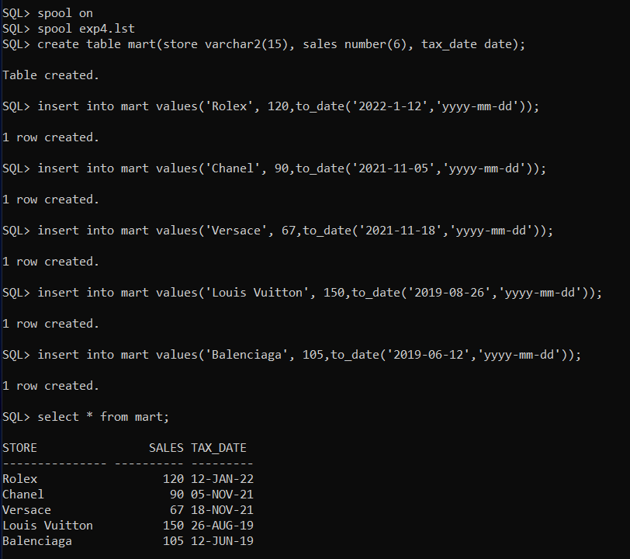

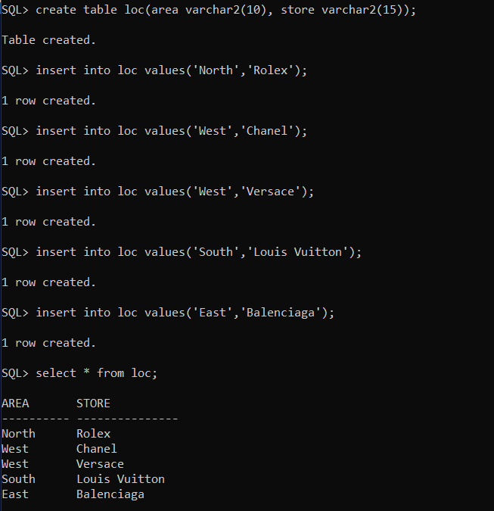

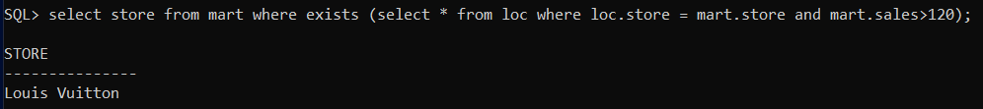

1. CASE – Used to find a value by passing over conditions whenever any condition satisfies the statement.

Syntax-

SELECT <column name>, CASE [expression] WHEN condition1 then value1 from <table-name>;

CODE-

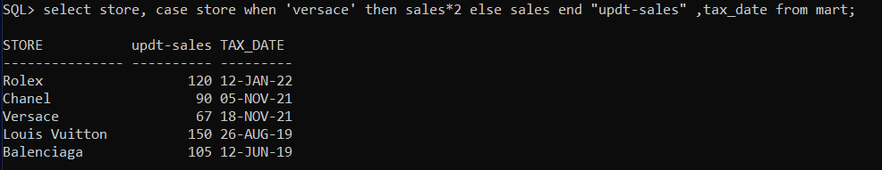

1. FETCH – Used to fetch the next row in the table.

Syntax-

SELECT <column name> from <table-name> FETCH FIRST 3 ROWS ONLY;

CODE-

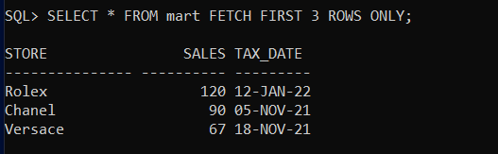

1. INTERSECT – Used to show distinct elements in two records in the table.

Syntax-

SELECT <column name> from <table-name> WHERE condition INTERSECT SELECT <column name> from <table-name> WHERE condition;

CODE-

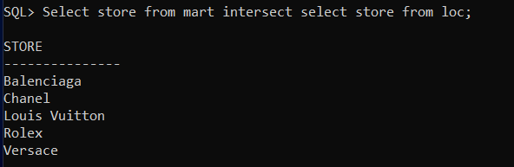

1. MINUS – Used to show unique element from 1st table.

Syntax-

SELECT <column name> from <table-name> WHERE condition MINUS SELECT <column name> from <table-name> WHERE condition;

CODE-

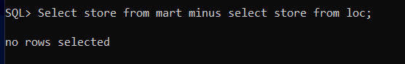

1. UNION – Used to combine two or more records in the table.

Syntax-

SELECT <column name> from <table-name> WHERE condition UNION SELECT <column name> from <table-name> WHERE condition;

CODE-

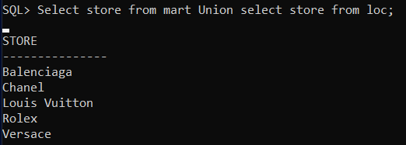

RESULT:

Thus, the Select advance commands have been executed successfully